Project 2
CS 557 - Computer Graphics Shaders
Name: Tianle Yuan (933-946-576)
Project Number: 2
Project Name:Noisy Elliptical Dots
Video Link: https://media.oregonstate.edu/media/1_hds2bgga
Email: yuant@oregonstate.edu
Time: January 16, 2020

Screen Captures：
Original Picture:
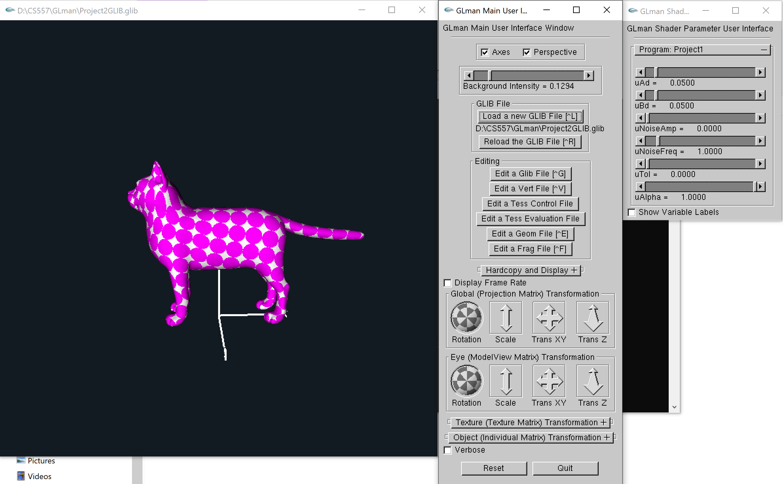

Change the variable UAd:
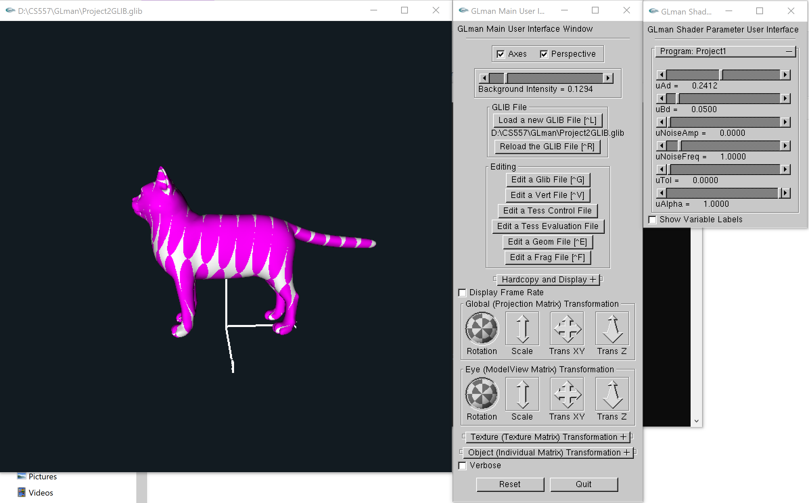
Change the value of variable uBd:
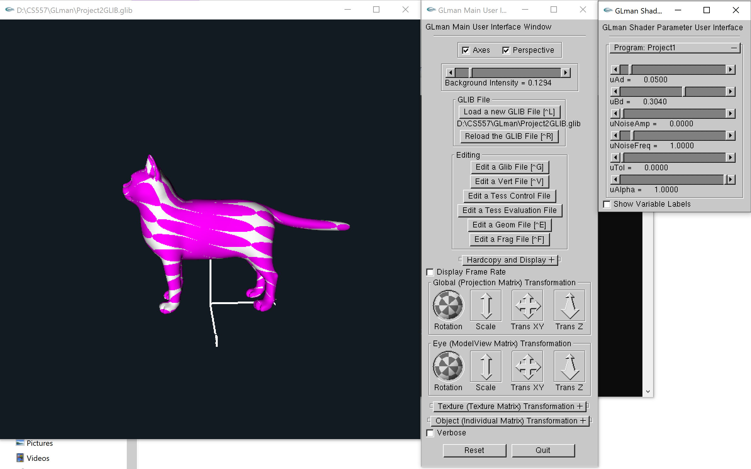

Change the value of variable uNoiseAmp:
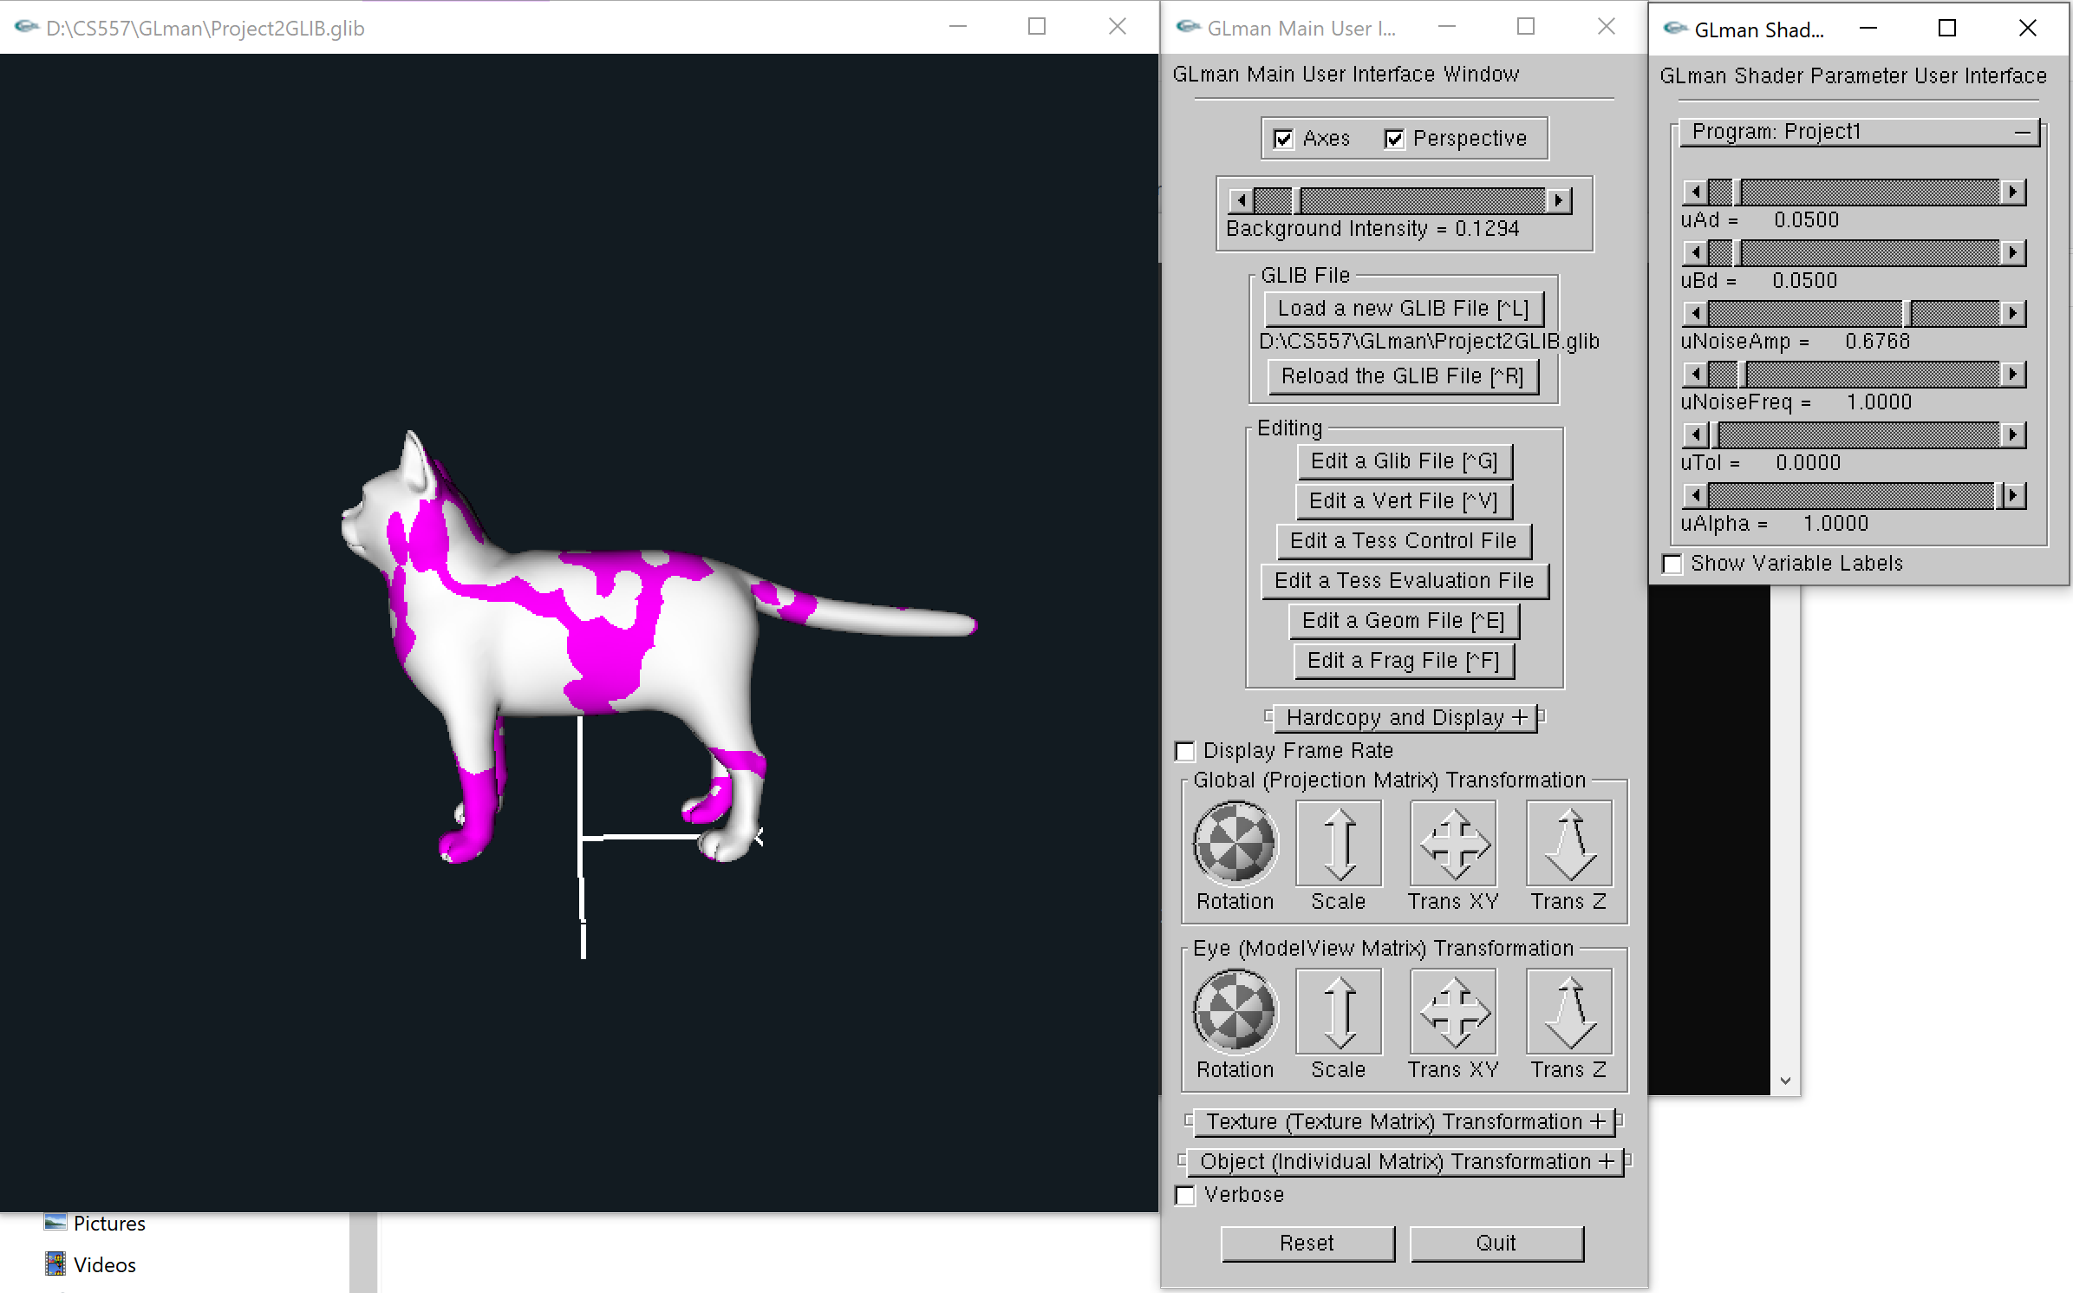
Increase the value of uNoiseFrequency:
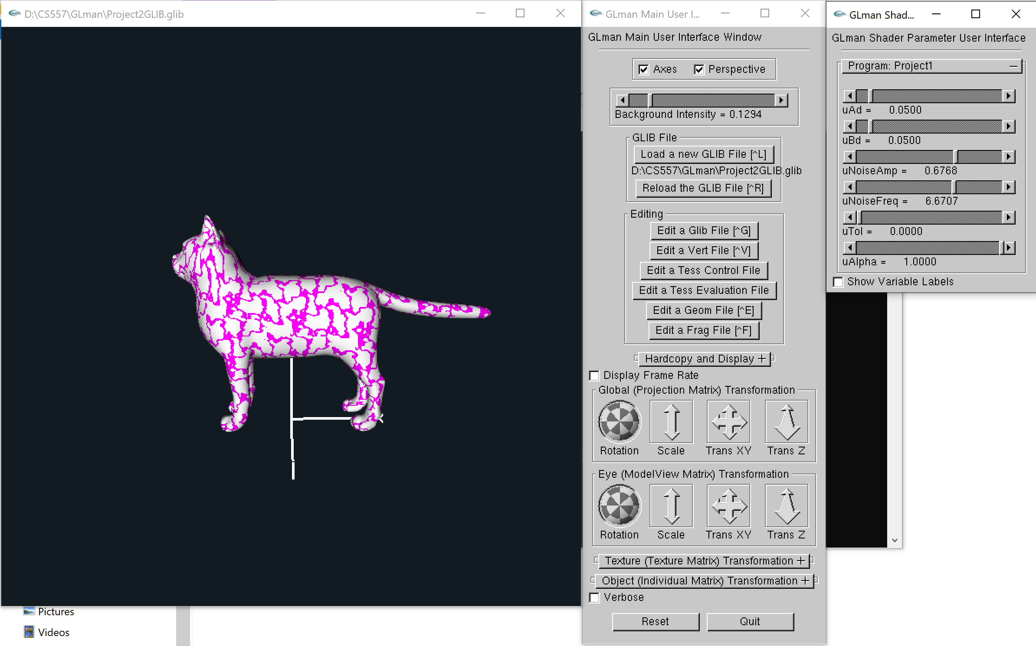

To blur the noise texture, increase the value of uTol:
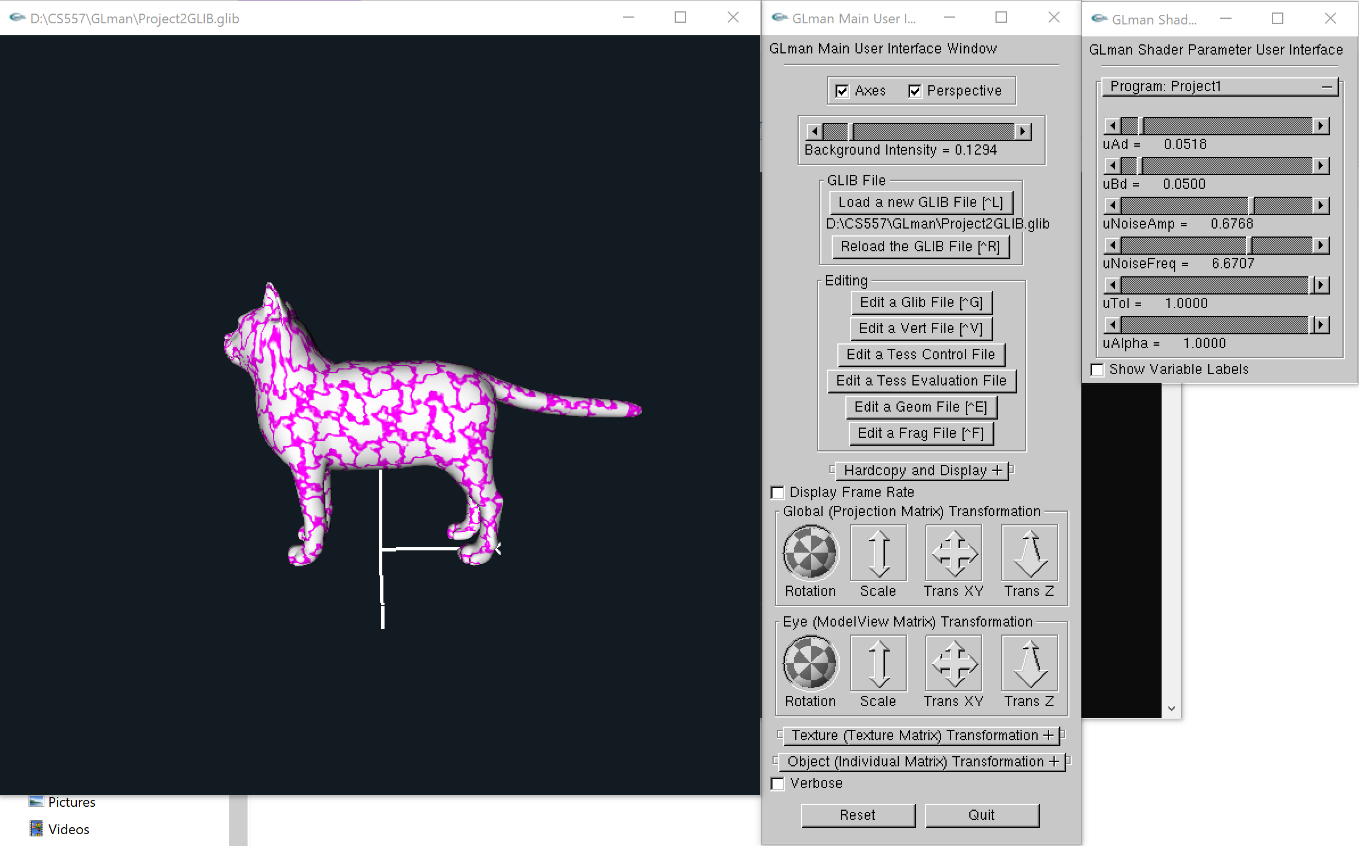
To see more clear about the blur, we magnify the graph. The left one have uTol = 0, the right one have uTol = 1:
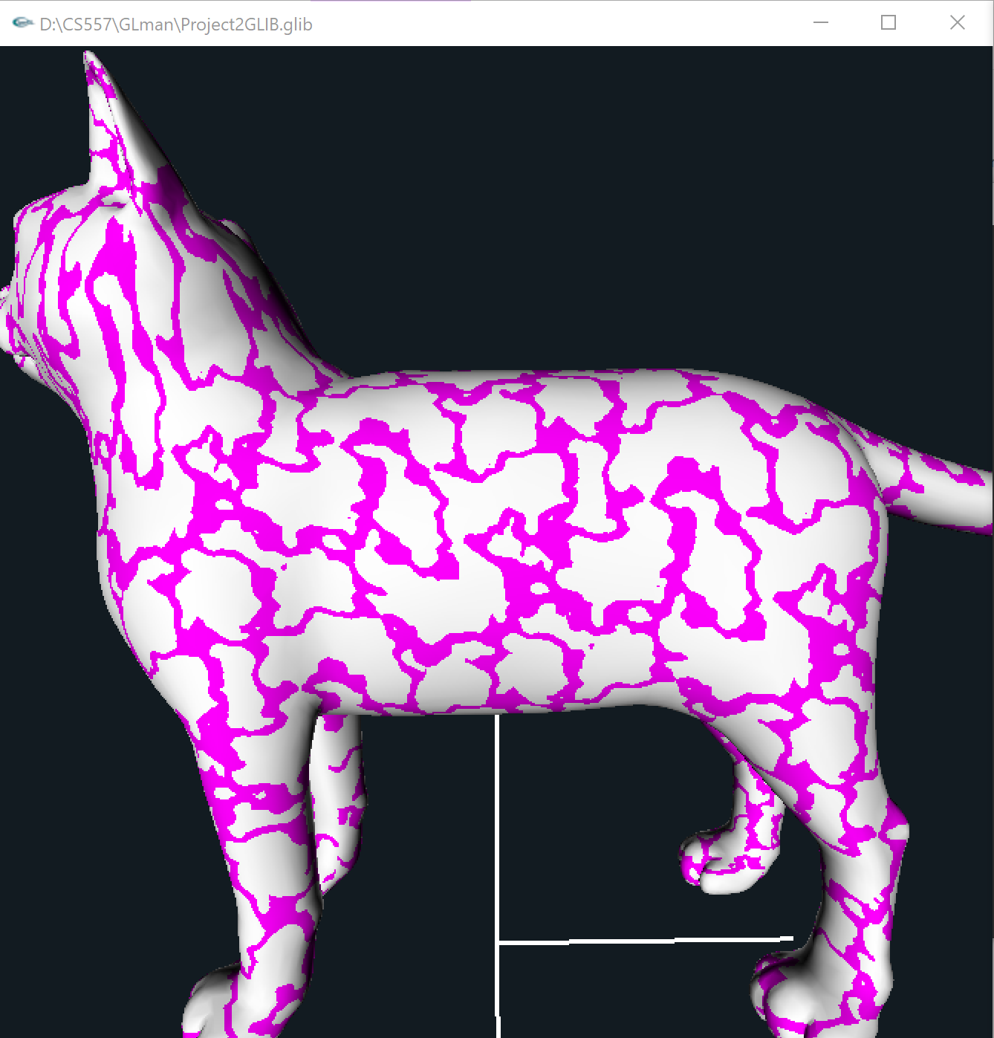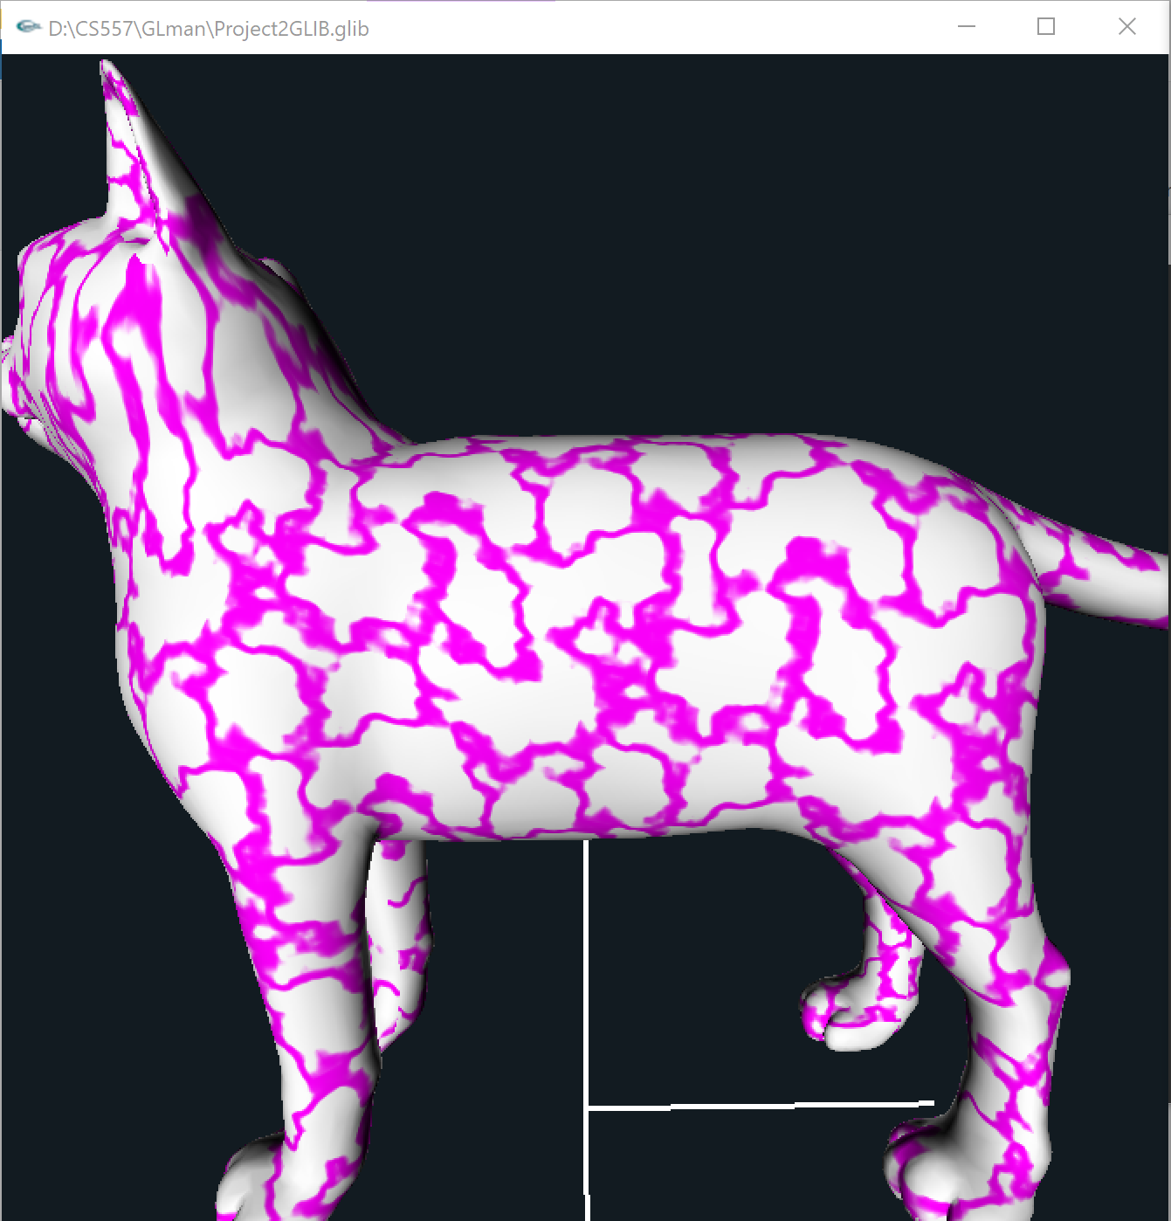

Finally, let’s change the uAlpha, when 0 < uAlpha < 1, it use blending:
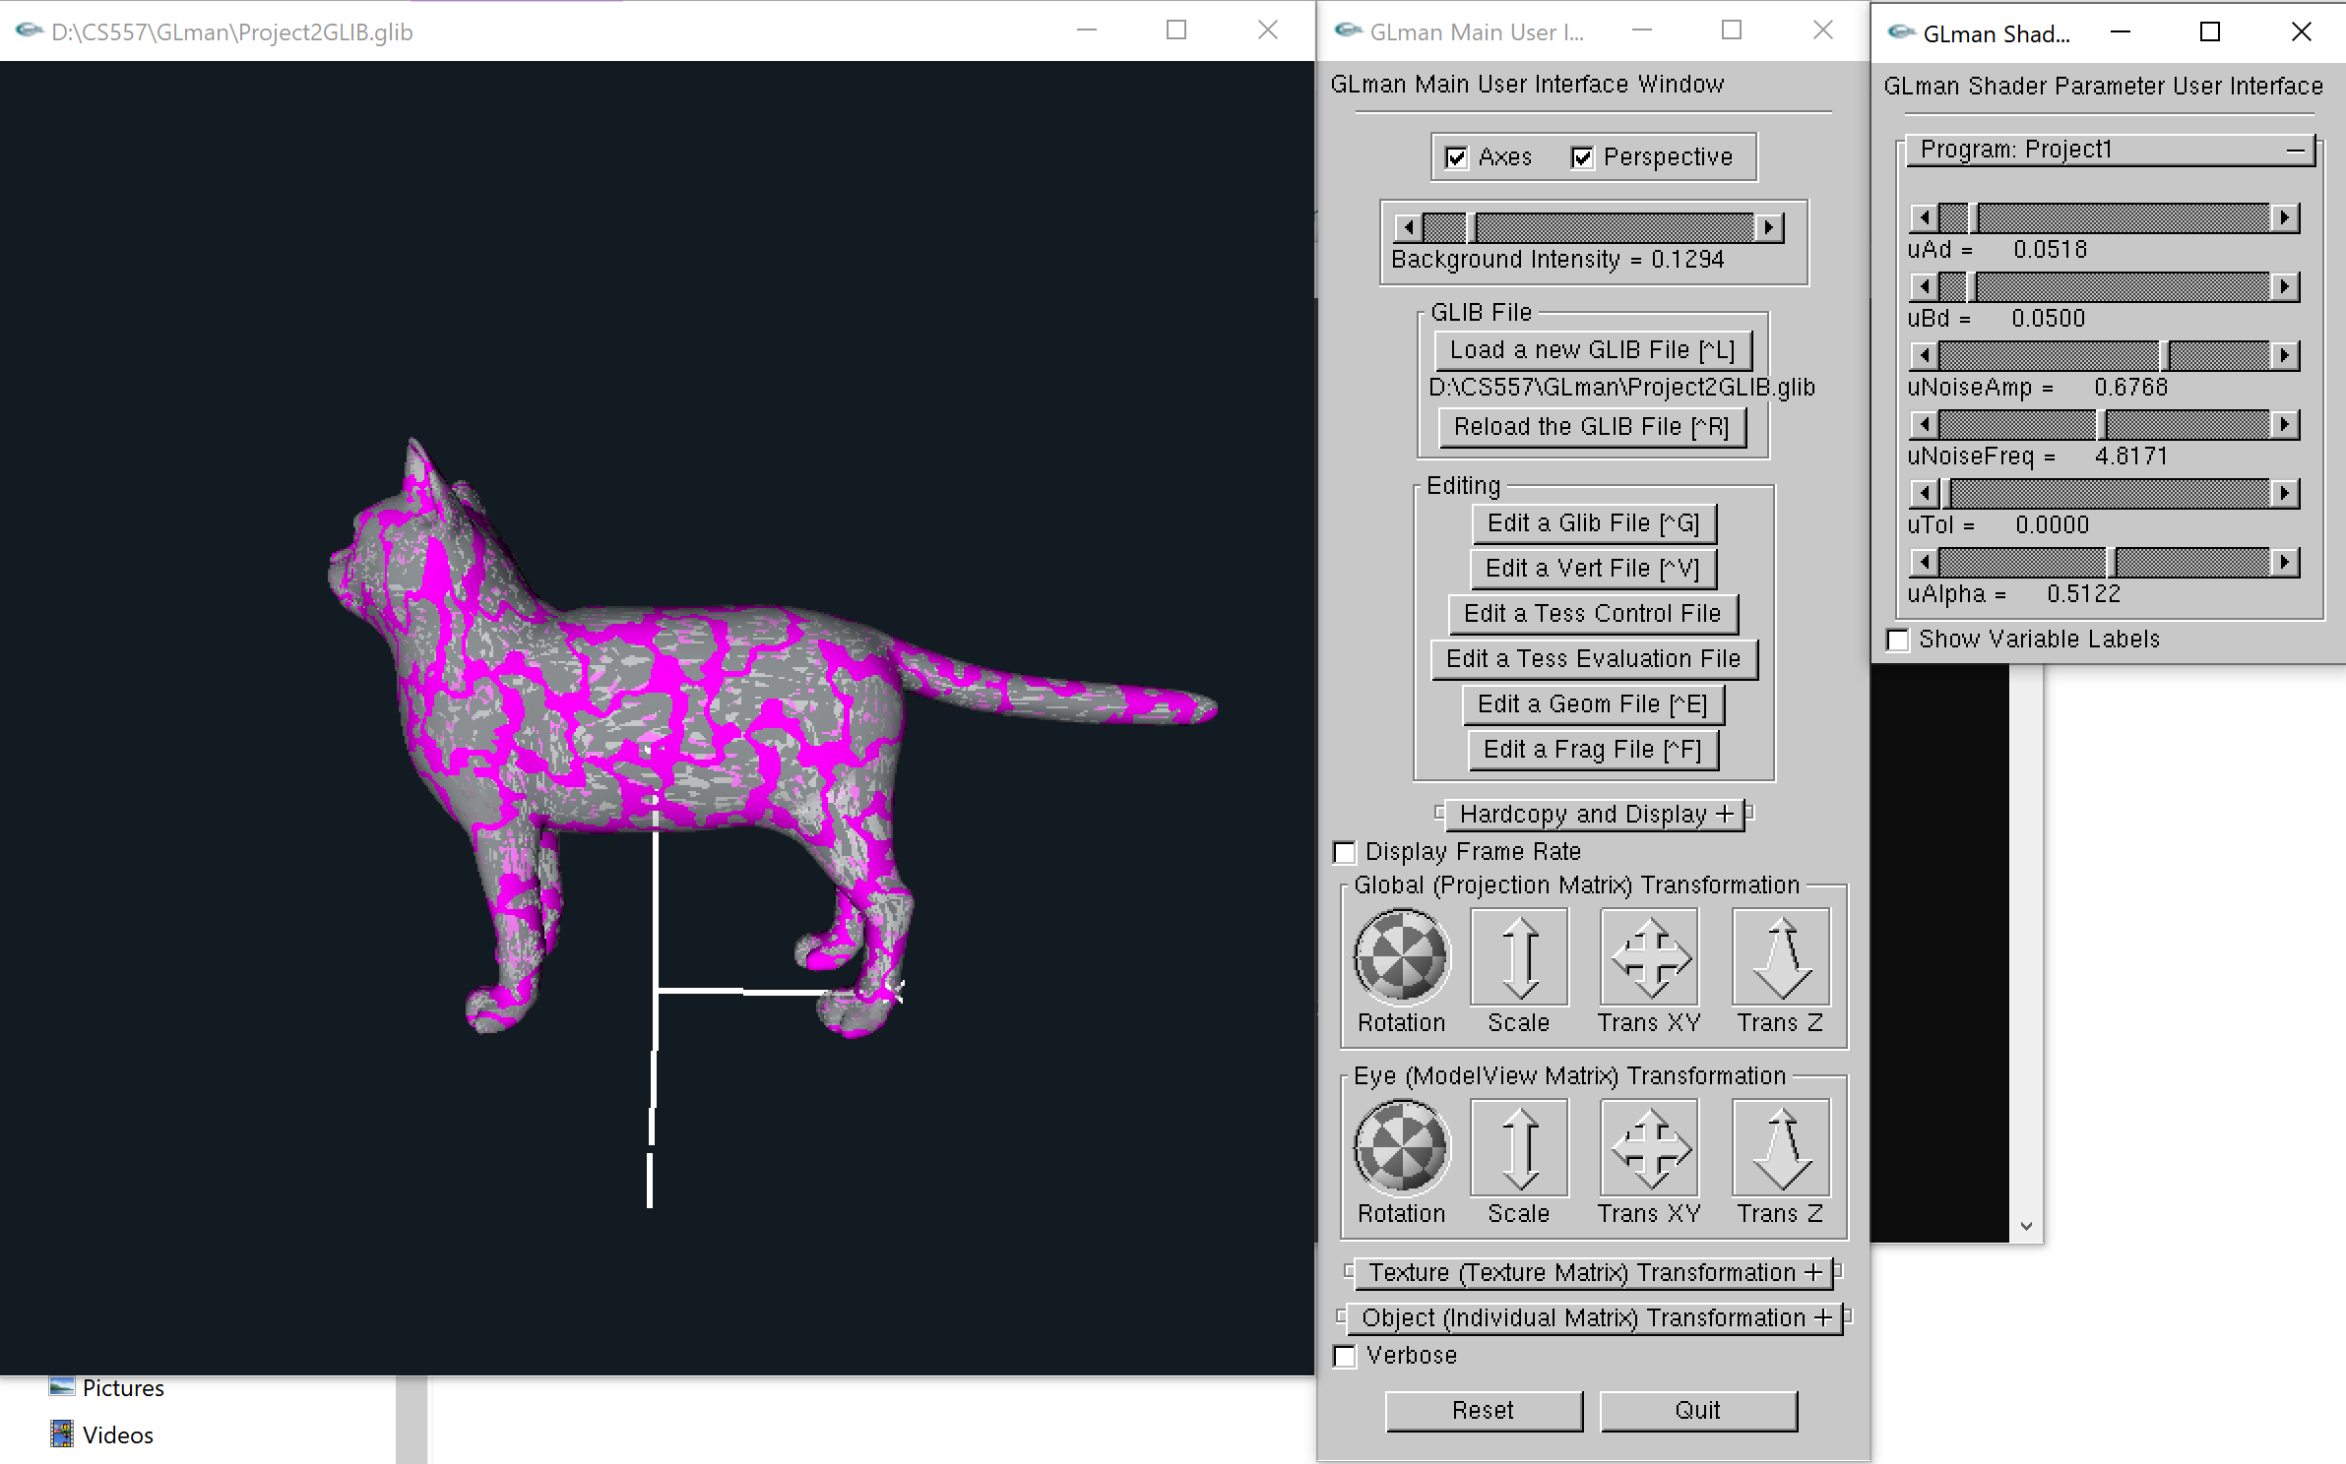

When uAlpha = 0, it use discard technique:
